**Network Fundamentals Lecture 10 Notes**

**Legacy Ethernet**

* Follows the rules of polite conversation
* - If no one else is talking, speak when you want to
* - If someone else is talking, wait until they are finished and then speak
* - If someone else starts to talk at the same time you do, both should stop and try again later
* This is Carrier Sense Multiple Access with Collision Detection (CSMA/CD)
* The collision happens when two devices try to transmit at the same time
* Devices attached to a LAN of this type share the bandwidth of the media
* - Shared Media LANs can only support a limited number of users
* - Generally limited by their limited size

**LAN Interface Cards and Addresses**

* Any transmission on a shared interface card (NIC) will reach every other LAN interface card
* Each NIC will have a unique LAN address
* It reads all broadcast messages
* It reads all multicast messages with addresses that it has been programmed to read
* The hardware of the NIC will ignore all other addresses
* Software drivers are associated with a LAN interface

**Ethernet LAN Access Devices**

* Client PC’s etc have a cable between their PC an access device in a Wire Closest
* This could be a repeater hub (legacy devices) or a switch
* Switches have become the dominant access device

**Access and distribution rules for shared media LANs**

* Access rules for Ethernet repeater hubs
* - Listen before send
* - Stop if multiple users start at the same time
* Distribution rules for Ethernet repeater hubs
* - All traffic goas everywhere
* - Only one packet at a time



* Access rules for switched Ethernet
* - Send whenever you want to
* - No collisions
* Distributed rules for switched Ethernet
* - Traffic only goes where it needs to go
* - Multiple Ethernet frames can be flowing



**Unicast (single destination addressing)**

* Unicast (one destination)
* Example: A client sending a frame to router to gain access to an external server



**Multicast (multiple but not all destinations) addressing**

* Not all destinations
* Example: A client PC is sending a multicast frame that will reach all servers



**Broadcast (All destinations) addressing**

* To everyone
* Example: A client PC is sending a broadcast frame that it wants to send to all devices



**How LANs Fit into Networking Model**

* LANs operate at the data link layer of our reference model
* IEEE divided the layers into two sub-layers
* - Logical link control (LLC)
* - Media Access Control (MAC)

**IEEE 802 LAN Standards**

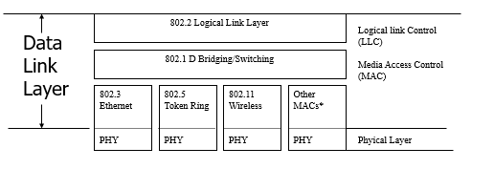

**Common Aspects of the LAN Standards**

* Things in common
* - All use the same address length (48 bits) (The MAC address)
* - Supports broadcast and multicast addresses (group addressing)
* - All have very good (32-bit) error checking
* - All standards are now in excess of 1Mbit/s

**Different Aspects of the LAN Standards**

* Things that differ
* - Access methods (CSMA/CD vs Token passing)
* - Maximum frame size
* - Support for features like priority
* - Specific data rate values

**Unique Addresses**

* IEEE 802 addresses are very long (48 bits)
* - Allowing them to be universally unique (No two NIC have the same address
* The manufacturer assigns the address to the interface
* - The LAN address id ‘burned in’
* This can be over ridden locally

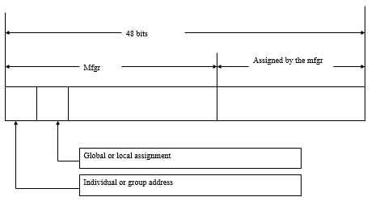

**The Variation of IEEE 802.3**

* 10 BASE5 (thickWire Ethernet) 10 mbit/s, baseband, 500m maximum
* 10 BASE 2 (thinWire Ethernet) 10 mbit/s, baseband, 185m maximum
* 10 BASE-T, uses unshielded twisted pair (UTP), 10mbit/s, baseband, 100m maximum
* 10 BASE-F, fibre optic ethernet (10mbit/s)
* 10 BASE-T and 100 BASE-F, 10mbit/s, baseband
* 1 Gigabit/s Ethernet (various forms)
* 10 Gigabit/s Ethernet

**10 BASE-T and 100 BASE-T**

* 10 BASE-T is a multiport repeater
* - Can support up to four hubs (four repeater sets) along a data path
* - 10mbit/s over two-pair Category 3 or better cabling
* - Supports up to 100m of cable length from the hub
* 100 BASE-T is a direct extension of 10 BASE-T
* - 100Mbit/s over two pair category 5e UTP (fast Ethernet)
* - Support up to 100m of cable length from the hub
* - Two 100BASE-T hubs can be interconnected

**Stackable Hubs and Switches**

* We often need more ports than one access device can support
* Some hubs and switches are stackable
* 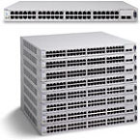

**Gigabit Ethernet**

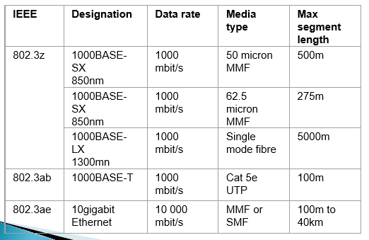

**10 Gbit/s Ethernet (802.3ae)**

* There is a never end demand for higher-data-rate communications
* Some things don’t change
* - Same 802.3 / Ethernet frame format
* - Same minimum and maximum frame size
* - Same structured cabling topologies
* Other things do change (for 1 and 10 Gbit/s)
* - No CSMA/CD
* - Only full duplex communication
* 10 Gbit/s will be used in MANs, large networks, SAN (a replacement for SONET/SDH networks)

**Legacy Ethernet**

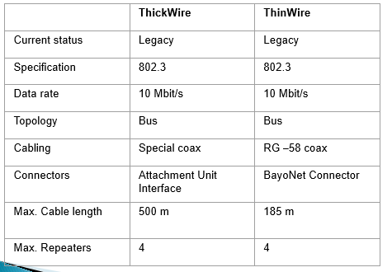

**Contemporary Ethernet**

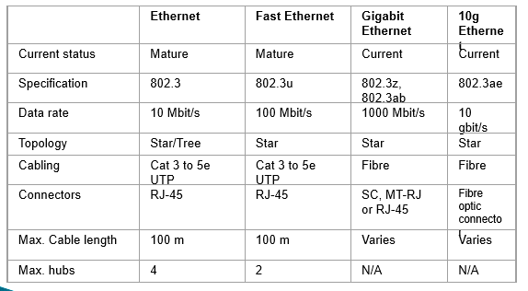

**IEEE 802.3 and Ethernet Version 2 Frame format**

* ISO 802-3

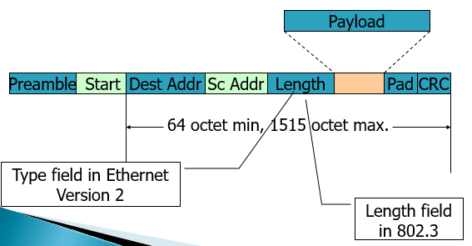

**Power over Ethernet (PoE)**

* Power over Ethernet utilizes the Ethernet cabling to deliver power to some Ethernet attached devices, such as
* - Ethernet telephones
* - Wireless Access Points
* - PoE defined in 802.3af
* Advantages
* - Power outlets may not be near
* - Backup power may not be available in everyone’s office

**Token Ring (802.5) and LLC (802.2)**

* These were devised to meet IBM networking needs
* Generally a legacy system but still in implementation
* Token ring is similar to polling
* - Polling is achieved via a three-octet’ token’ that circulates around the ring
* - If you have the token you can send one frame and then you must pass the token on
* Token ring provides configurable options
* - 8 levels of priority
* - Selectable maximum frame size

**Switching and Transparent Spanning Tree**

* Switches perform a form of forwarding
* - Find the path to the destination device
* The switches automatically form a tree topology
* - No Closed loops
* - Any possible loops result in some links being placed in standby mode
* Switches learn by observing traffic
* - Traffic originates on one side of the bridge
* The learning process is based on source addresses

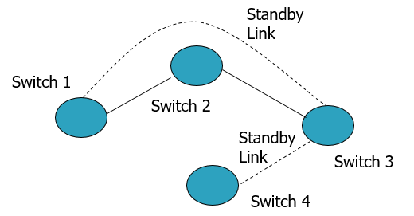

**Switched Ethernet**

* Switched Ethernet is a hardware implementation of bridging
* Switched Ethernet Characteristics
* - Automatically learns source address
* - Forwards selectively to the destination
* - Supports many ports per switch
* - Supports full duplex on dedicated ports
* Switches can support different data rates on each port
* Ethernet switches normally operate in store-and-forward mode
* - Temporarily hold the frame while making forwarding decisions
* Some Ethernet switches may also support cut-through operation
* - Start to forward after receiving the destination-address part of the frame (if the output port id is free and of the same data rate)
* Cut-through reduces the delay in getting through the switch

**Virtual LANs**

* Software gives an appearance of a physical connection
* Purpose is to limit broadcast traffic to a defined group – workgroup
* The workgroup is defined by network management
* Membership is by:
* - Selecting a set of ports on a hub
* - Select a set of MAC addresses
* - Layer 3 protocol type (e.g. IP or IPX)
* The network manager configures the VLAN membership
* - Better than putting down new cables
* Multiple VLANs can be configured